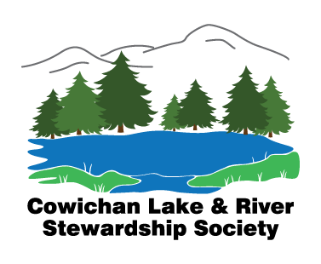

CLRSS Annual General Meeting - Sunday, May 30, 2021 - 10:00 - 12:00 Zoom meeting

Year April 1, 2020 to March 31, 2021

Minutes:

10:00 President, Ken Traynor, presiding
Call to Order at 10:00 – Number in attendance recorded as 18
Fourfold Way reviewed:
- respect each other by having just one speaker at a time,
- expect people to speak from the heart with passion,
- expect people to show up to solve problems, and
- expect people to speak without blame.

We acknowledged that we are meeting on the traditional territories of the Ts'uubaa-asatx, Ditidaht and Quw’utsun First Nations. We hope that our work together here today will make a positive contribution to our shared future in this valley.
A reminder was made that while guests are always welcome, only those members in good standing may vote on motions at this meeting.
General Welcome and thanks were expressed to the 2020/21 Board of Directors and to our volunteers by President, Ken Traynor.,
1.) Adoption of the Agenda:
Moved by Diana Gunderson and seconded by Rosemary Danaher that the 2021 AGM agenda be adopted as distributed. CARRIED
2.) Approval of the Minutes of the Annual General Meeting of June 28th, 2020:
Moved by Judy Brayden and seconded by Lyndon Keeping that the minutes of the CLRSS AGM of June 28th, 2020, be adopted as distributed. CARRIED
3.) CLRSS Committee Reports in form of a PowerPoint were presented by President, Ken Traynor. Project Leads commented and answered questions.
Moved by Diana Gunderson and seconded by Rosemary Danaher that the 2020/21 CLRSS committee reports be accepted as presented. CARRIED
4.) Election of 2021-2022 CLRSS Board of Directors: Ian Morrison chaired this portion of the meeting.
Executive Directors:
President - Ken Traynor
Vice President and Treasurer - Lyndon Keeping
Secretary - Judy Brayden

Members At Large:
Di Gunderson
Rosemary Danaher
Chantelle Carden
Jim Deck
Dave DePape
Rodger Hunter

NOTE: Rick Bryan and Jean Atkinson have agreed to accept appointment to the 2021/22 CLRSS Board of Directors once 30 days has passed from the renewal date of his CLRSS membership.

This CLRSS Board of Directors was adopted by the consensus of the meeting.

5.) Special presentation:

Long time CLRSS member, Lois Atchison was presented with an honorary, lifetime membership in the society. Diana Gunderson spoke to Lois’ service and contributions to the society since its outset and presented her with her certificate. She was also given an original, raku bird made by ceramic artist, Rosemary Danaher.

Two further presentations will be made at the June 7th regular Board meeting.

6.) Procedural Motions:

Moved by Judy Brayden and seconded by Lyndon Keeping that the society’s signing authority be changed to reflect the newly elected Board of Directors. CARRIED

Moved by Bee Greenway and seconded by Lyndon Keeping that the members agree to waive an audit of the 2022/21 financial report. CARRIED

7.) Motion to adjourn: Bee Greenway

